* Introduction
* Installation Steps
* Architecture
* Supported Data Sources
* Comparison with Other BI Tools
* Power BI - Data Modeling

**Introduction**

Power BI is a Data Visualization and Business Intelligence tool that converts data from different data sources to interactive dashboards and BI reports.

Power BI suite provides multiple software, connector, and services - Power BI desktop, Power BI service based on Saas, and mobile Power BI apps available for different platforms.

Power BI Desktop is available in both 32-bit and 64-bit versions. To download the latest version, you can use the following link −

<https://powerbi.microsoft.com/en-us/downloads/>

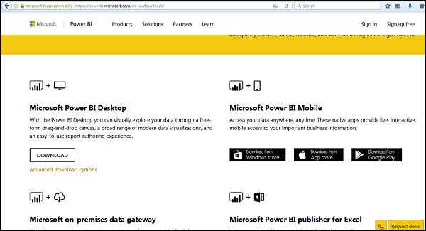

Installation Steps

To check the system requirements, installation files detail, users have to navigate to “Advanced download options”. Following are the system requirements to download Power BI tool −

## Supported Operating Systems

* Windows 10, Windows 7, Windows 8, Windows 8.1, Windows Server 2008 R2, Windows Server 2012, Windows Server 2012 R2
* Microsoft Power BI Desktop requires Internet Explorer 9 or higher
* Microsoft Power BI Desktop is available for 32-bit (x86) and 64-bit (x64) platforms

Users can select a language in which they want to install Power BI and following files are available for download.

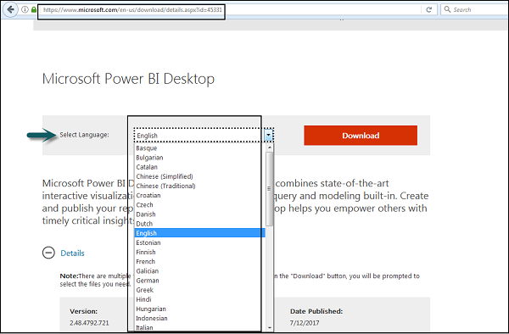

This is the link to directly download Power BI files −

<https://www.microsoft.com/en-us/download/details.aspx?id=45331>

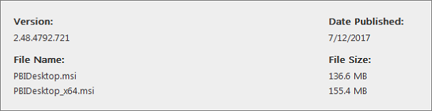

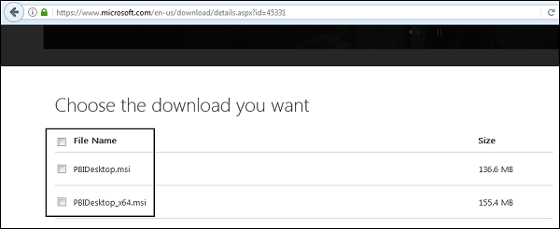

Note: MIS (Microsoft installer )

PBIDesktop_x64.msi shows a 64-bit OS file. Select the file you want to install as per OS type and click Next. Save the installation file on the local drive.

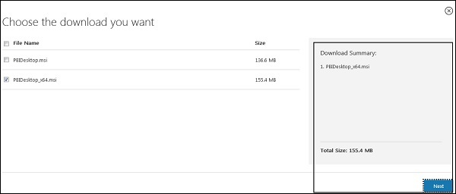

When you run the installation file, following screen is displayed.

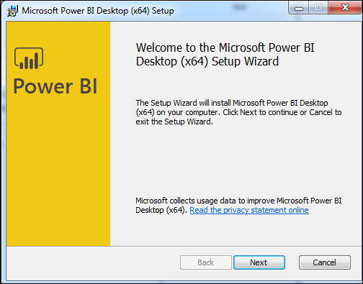

Accept the license agreement and follow the instructions on the screen to finish the installation.

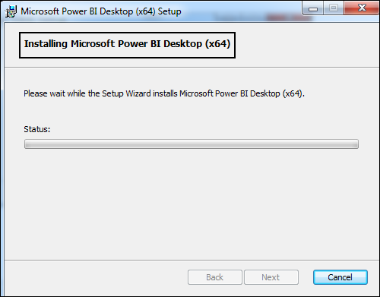

When Power BI is installed, it launches a welcome screen. This screen is used to launch different options related to get data, enrich the existing data models, create reports as well as publish and share reports.

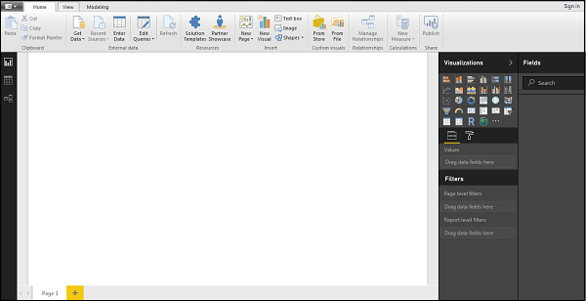

# Power BI – Architecture

Power BI includes the following components −

* **Power BI Desktop** − This is used to create reports and data visualizations on the dataset.
* **Power BI Gateway** − You can use Power BI on-premises gateway to keep your data fresh by connecting to your on-premises data sources without the need to move the data. It allows you to query large datasets and benefit from the existing investments.
* **Power BI Mobile Apps** − Using Power BI mobile apps, you can stay connected to their data from anywhere. Power BI apps are available for Windows, iOS, and Android platform.
* **Power BI Service** − This is a cloud service and is used to publish Power BI reports and data visualizations.

# Power BI Components

# Supported Data Sources

Power BI supports large range of data sources. You can click Get data and it shows you all the available data connections. It allows you to connect to different flat files, SQL database, and Azure cloud or even web platforms such as Facebook, Google Analytics, and Salesforce objects. It also includes ODBC connection to connect to other ODBC data sources, which are not listed.

Following are the available data sources in Power BI −

* Flat Files : csv(comma separate version) , .txt, .dat, Excel

Example: csv

Id,name,sal

111,nitin,222

* SQL Database: MS SQL Server
* OData Feed
* Blank Query
* Azure Cloud platform
* Online Services
* Blank Query
* Other data sources such as Hadoop, Exchange, or Active Directory

To get data in Power BI desktop, you need to click the Get data option in the main screen. It shows you the most common data sources first. Then, click the More option to see a full list of available data sources.

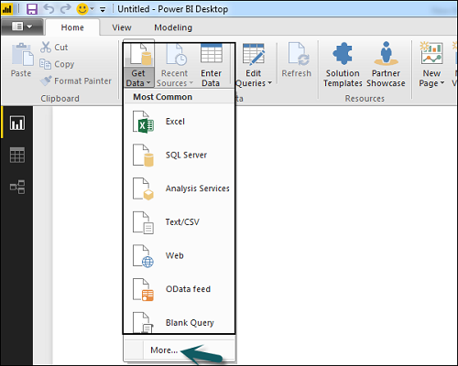

When you click “More..” tab as shown in the above screenshot, you can see a new navigation window, where on the left side it shows a category of all available data sources. You also have an option to perform a search at the top.

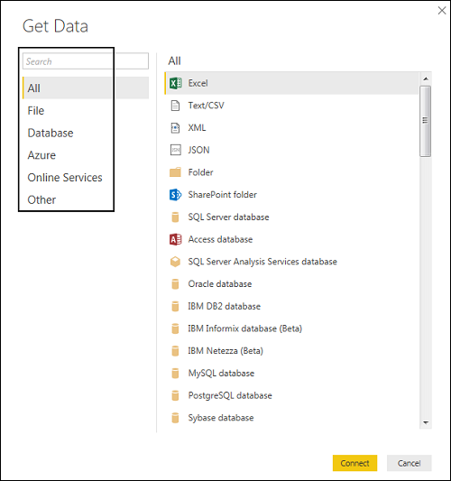

Following are the various **data sources** listed −

## All

Under this category, you can see all the available data sources under Power BI desktop.

## File

When you click File, it shows you all flat file types supported in Power BI desktop. To connect to any file type, select the file type from the list and click Connect. You have to provide the location of the file.

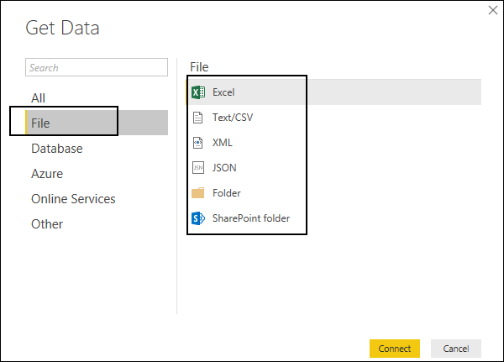

## Database

When you click the Database option, it shows a list of all the database connections that you can connect to.

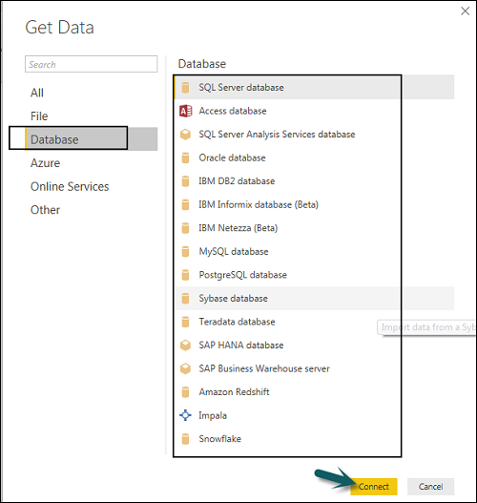

To connect to any database, select a Database type from the list as shown in the above screenshot. Click Connect.

You have to pass Server name/ User name and password to connect. You can also connect via a direct SQL query using Advance options. You can also select Connectivity mode- Import or DirectQuery.

**Note** − You can’t combine import and DirectQuery mode in a single report.

## Import vs DirectQuery

**DirectQuery** option limits the option of data manipulation and the data stays in SQL database. DirectQuery is live and there is no need to schedule refresh as in the Import method.

**Import** method allows to perform data transformation and manipulation. When you publish the data to PBI service, limit is 1GB. It consumes and pushes data into Power BI Azure backend and data can be refreshed up to 8 times a day and a schedule can be set up for data refresh.

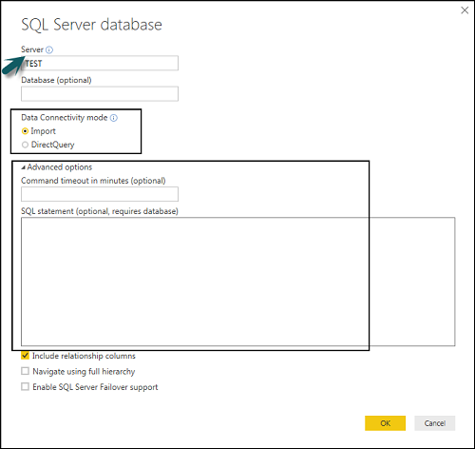

## Advantages of Using DirectQuery

* Using DirectQuery, you can build data visualizations on large datasets, which is not feasible to import in Power BI desktop.
* DirectQuery doesn’t apply any 1GB data set limit.
* With the use of DirectQuery, the report always shows current data.

## Limitations of Using DirectQuery

* There is a limitation of 1 million row for returning data while using DirectQuery. You can perform aggregation of more number of rows, however, the result rows should be less than 1 million to return the dataset.
* In DirectQuery, all tables should come from a single database.
* When a complex query is used in the Query editor, it throws an error. To run a query, you need to remove the error from the query.
* In DirectQuery, you can use Relationship filtering only in one direction.
* It doesn’t support special treatment for time-related data in tables.

## Azure

Using the Azure option, you can connect to the database in Azure cloud. Following screenshot shows the various options available under Azure category.

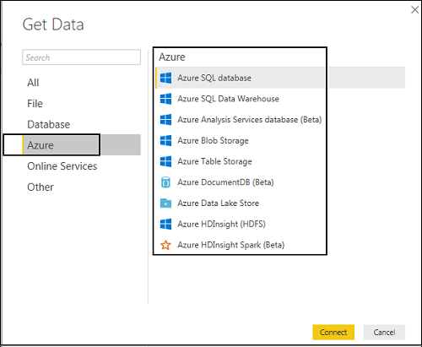

## Online Services

Power BI also allows you to connect to different online services such as Exchange, Salesforce, Google Analytics, and Facebook.

Following screenshots shown the various options available under Online Services.

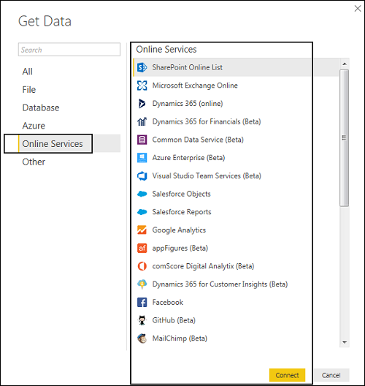

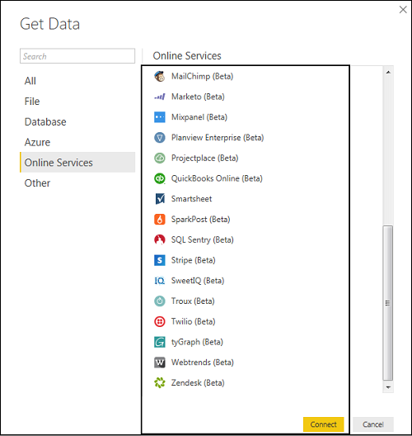

## Other

Following screenshot shows the various options available under other category.

# Other Category

# Comparison with Other BI Tools

## Power BI vs Tableau

Tableau is considered as one of the leading tools in the BI market. Power BI is considered as an emerging tool in close competition with Tableau because of its backend data manipulation features and connectivity with the list of data sources. Tableau is one of the best data visualization tools in the market and is used by medium and large enterprises. Power BI is closely integrated with Office 365 suite, and hence it is compatible other sources such as SharePoint.

|  |  |  |
| --- | --- | --- |
| **Feature** | **Tableau** | **Power BI** |
| Data Visualization | Tableau provides strong data visualization and is one of the main data visualization tool in the market. | Power BI provides a strong backend data manipulation feature with access to simple visualizations. |
| Size of Dataset | Tableau can connect much larger datasets as compared to Power BI. | Power BI has a limit of 1GB data in free version. |
| Data Sources | Tableau covers a vast range of data sources to connect with for data visualization. In Tableau, you select the dataset first and visualizations are used on the fly. | Power BI covers most of the data sources available in Tableau. It is closely integrated with Office 365, hence provides connectivity to SharePoint.  Power BI online version also supports direct visualization on Search Engine, though, only Bling is supported at this point. |
| Costing | Tableau is expensive as compared to Power BI but still under budget for small and medium enterprise. | Power BI provides a free version with 1GB limit on dataset. Power BI Pro is also a cheaper solution when compared with any other BI tool. |
| License and Pricing | Tableau Desktop Profession: USD70/user/month and it can connect to hundreds of data sources.  Tableau Desktop Personal: USD35/user/month and it can connect to data sources such as Google Sheets and Excel files.  Tableau Server: Minimum 10 users with the cost of USD35/user/month  Tableau Online with private cloud: USD 42/user/month | Power BI: Free  1 GB storage  10k rows/hour data streaming  Power BI Pro:  USD9.99/user/month  10 GB storage  1 million rows/hour |
| Implementation | Tableau provides different implementation types as per organizational needs panning from few hours to few weeks. | Power BI uses cloud storage and includes simple implementation process. |

## Power BI vs SSRS

|  |  |  |
| --- | --- | --- |
| **Feature** | **SSRS** | **Power BI** |
| Data Visualization | SSRS is mostly used for Pixel perfect reporting and average dash-boarding features. | Power BI provides a strong backend data manipulation feature with access to simple visualizations. |
| Size of Dataset | No such limit in SSRS. It can connect to much larger datasets as compared to Power BI. | Power BI has a limit of 1GB data in free version. |
| Data Sources | SSRS covers a vast range of data sources to connect with for BI reporting. | Power BI covers most of the data sources available in Tableau. It is closely integrated with Office 365, hence provides connectivity to SharePoint.  Power BI online version also supports direct visualization on Search Engine, though, only Bling is supported at this point. |
| Costing | SSRS pricing details are available only upon request. | Power BI provides a free version with 1GB limit on dataset. Power BI Pro is also a cheaper solution when compared with any other BI tool. |
| License and Pricing | SQL Server Enterprise License. It is available on cloud - AWS, Azure, and other providers. | Power BI: Free  1 GB storage  10k rows/hour data streaming  Power BI Pro:  USD9.99/user/month  10 GB storage  1 million rows/hour |
| Implementation | SSRS implementation is complex as compared with Power BI. | Power BI uses cloud storage and includes simple implementation process. |

# Data Modeling

## Using Data Modeling and Navigation

Data Modeling is one of the features used to connect multiple data sources in BI tool using a relationship.

A relationship defines how data sources are connected with each other and you can create interesting data visualizations on multiple data sources.

With the modeling feature, you can build custom calculations on the existing tables and these columns can be directly presented into Power BI visualizations.

**Relationship Type in Data Model:**

* 1. 1:1 (example: employee -> salary )
  2. 1:M (example: employee -> attendance )
  3. M:1 (example: attendance -> employee )
  4. M:M (example: project , Employee -> ProjectAllocation)

This allows businesses to define new metrics and to perform custom calculations for those metrics.

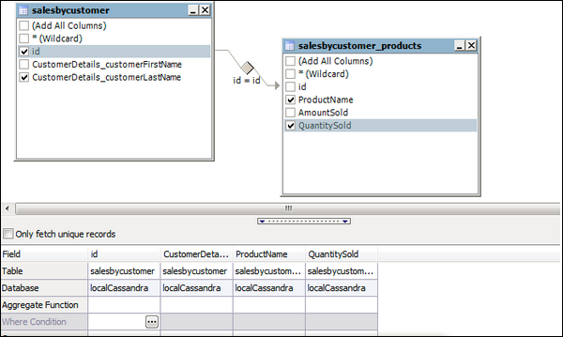

In the above image, you can see a common data model, which shows a relationship between two tables. Both tables are joined using a column name “Id”.

Similarly, in Power BI, you set the relationship between two objects. To set the relationship, you have to drag a line between the common columns. You can also view the “Relationship” in a data model in Power BI.

To create data model in Power BI, you need to add all data sources in Power BI new report option. To add a data source, go to the Get data option. Then, select the data source you want to connect and click the Connect button.

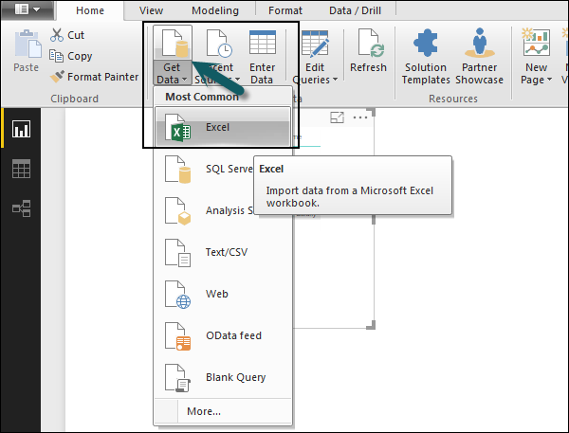

Once you add a data source, it is presented on the right side bar. In the following image, we have used 2 xls file to import data - Customer and Product.

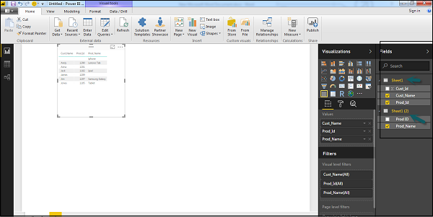

In Power BI on the left side of the screen, you have the following three tabs −

* Report
* Data
* Relationships

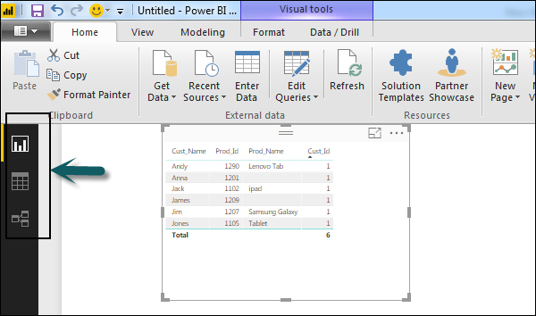

When you navigate to the Report tab, you can see a dashboard and a chart selected for data visualization. You can select different chart types as per your need. In our example, we have selected a Table type from available Visualizations.

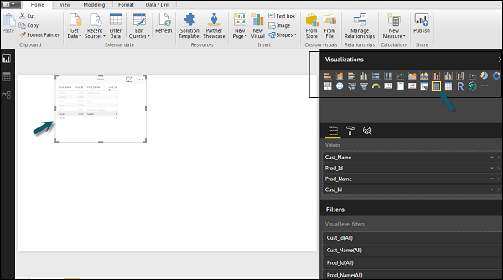

When you go to the Data tab, you can see all the data as per the defined Relationship from the data sources.

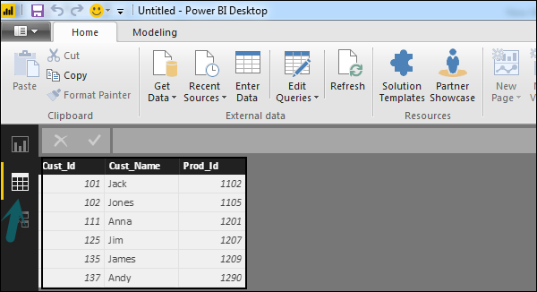

In the Relationship tab, you can see the relationship between data sources. When you add multiple data sources to Power BI visualization, the tool automatically tries to detect the relationship between the columns. When you navigate to the Relationship tab, you can view the relationship. You can also create a Relationship between the columns using Create Relationships option.

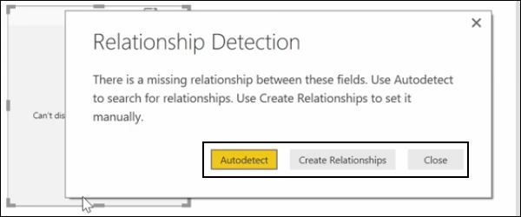

You can also add and remove relationships in data visualization. To remove a relationship, you have to right-click and select the “Delete” option. To create a new “Relationship”, you just need to drag and drop the fields that you want to link between the data sources.

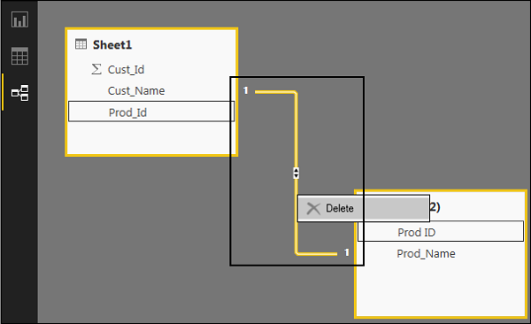

You can also use the Relationship view to hide a particular column in the report. To hide a column, right-click on the column name and select the “Hide in report view” option.

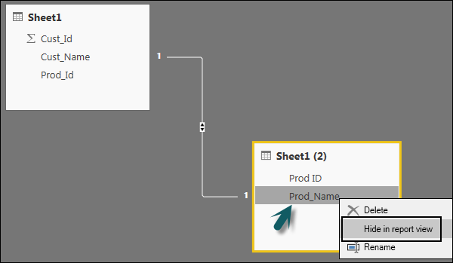

## Creating Calculated Columns

You can create calculated columns in Power BI by combining two or more elements of the existing data. You can also apply calculation on an existing column to define a new metric or combine two columns to create one new column.

You can even create a calculated column to establish a relationship between the tables and it can also be used to setup a relationship between two tables.

To create a new calculated column, navigate to Data View tab on the left side of the screen and then click Modeling.

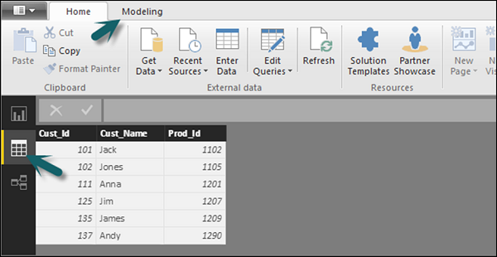

When you navigate to the Modeling tab, you can see a New Column option at the top of the screen. This also opens the formula bar, where you can enter DAX formula to perform calculation. DAX- Data Analysis Expression is a powerful language also used in Excel to perform calculations. You can also rename the column by changing the Column text in the formula bar.

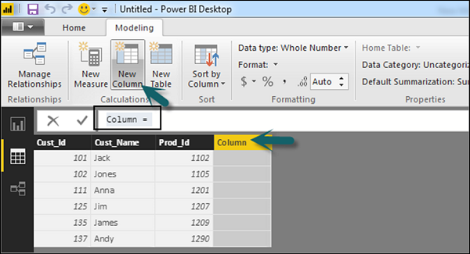

In the following example, let us create a new column: Product Code (Product_C), which is derived from the last three characters of Prod_Id column. Then, write the following formula −

Product_C = RIGHT( Sheet1[Prod_Id],3)

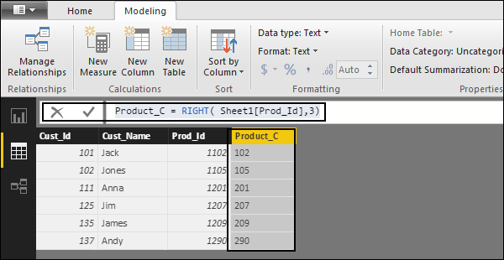

A long list of formulas is also provided that you can use for creating calculated columns. You have to enter the first character of formula to be used in calculations as shown in the following screenshot.

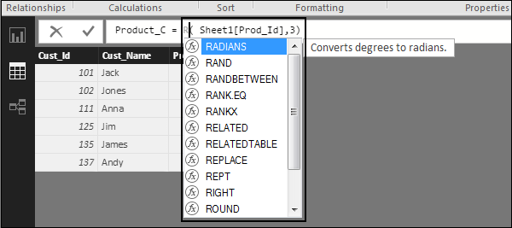

## Creating Calculated Tables

You can also create a new calculated table in data modeling in Power BI. To create a new table, navigate to the Data View tab on the left side of the screen, and then go to the Modeling option at the top of the screen.

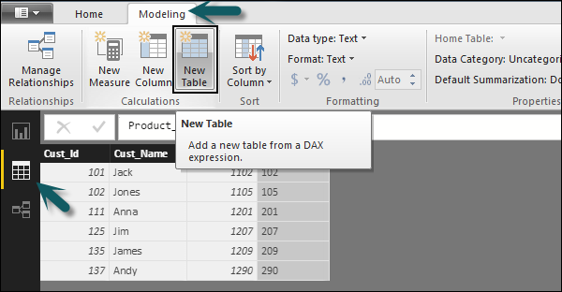

DAX expression is used to create the new table. You have to enter the name of a new table on the left side of the equal sign and DAX formula to perform the calculation to form that table on the right. When the calculation is complete, the new table appears in the Fields pane in your model.

In the following example, let us define a new table - Table_CustC that returns a one column table containing unique values in a column in another table.

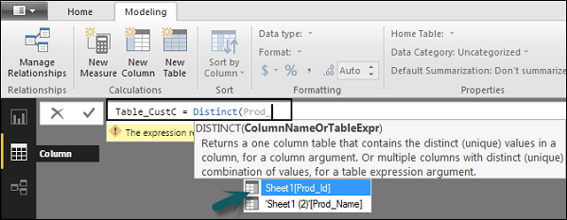

A new table is added under the “Fields” section in Power BI screen as shown in the following screenshot. Once the calculated column and calculated tables are created as per your requirement, you can use the fields in the Report tab in Power BI.

To add these objects, you have to select a checkbox and a relationship is automatically detected if possible. If not, then you can drag the columns that you want to connect.

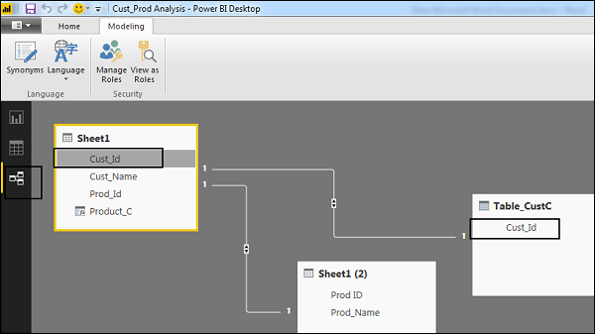

To view the report, you navigate to the Report tab and you can see both “Calculated columns” and fields from the new “Calculated table” in the report view.

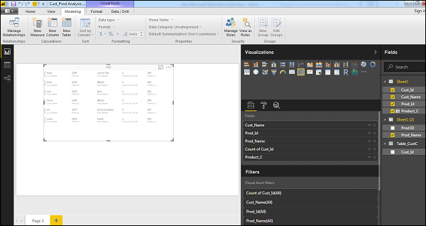

## Managing Time-Based Data

Power BI allows to drill through time-based data by default. When you add a date field in your analysis and enable drill on your data visualization, it takes you to the next level of time-based data.

Let us consider we have added Time-based table in Power BI visualization. We have added Revenue and Year column in our report.

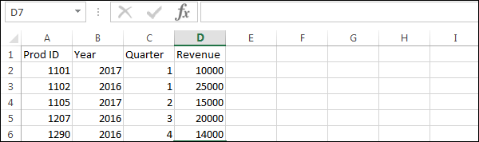

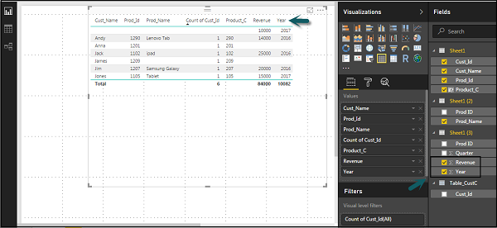

We can enable the drill feature in visualizations using the option at the top. Once we enable the drill feature and click the bars or lines in the chart, it drills down to the next level of time hierarchy. **Example:** Years → Quarters → Months.

We can also use Go to the next level in the hierarchy option to perform a Drill.

# Hierarchy Option

**SQL Server Name:** LH7U05CG7300QJQ\DBS92

**Database name:** hrms

**Authentication Mode:**

1. Windows (default)
2. SQL Server

**Tables:**

* Emp
* Sal